1. Create project structure like this:

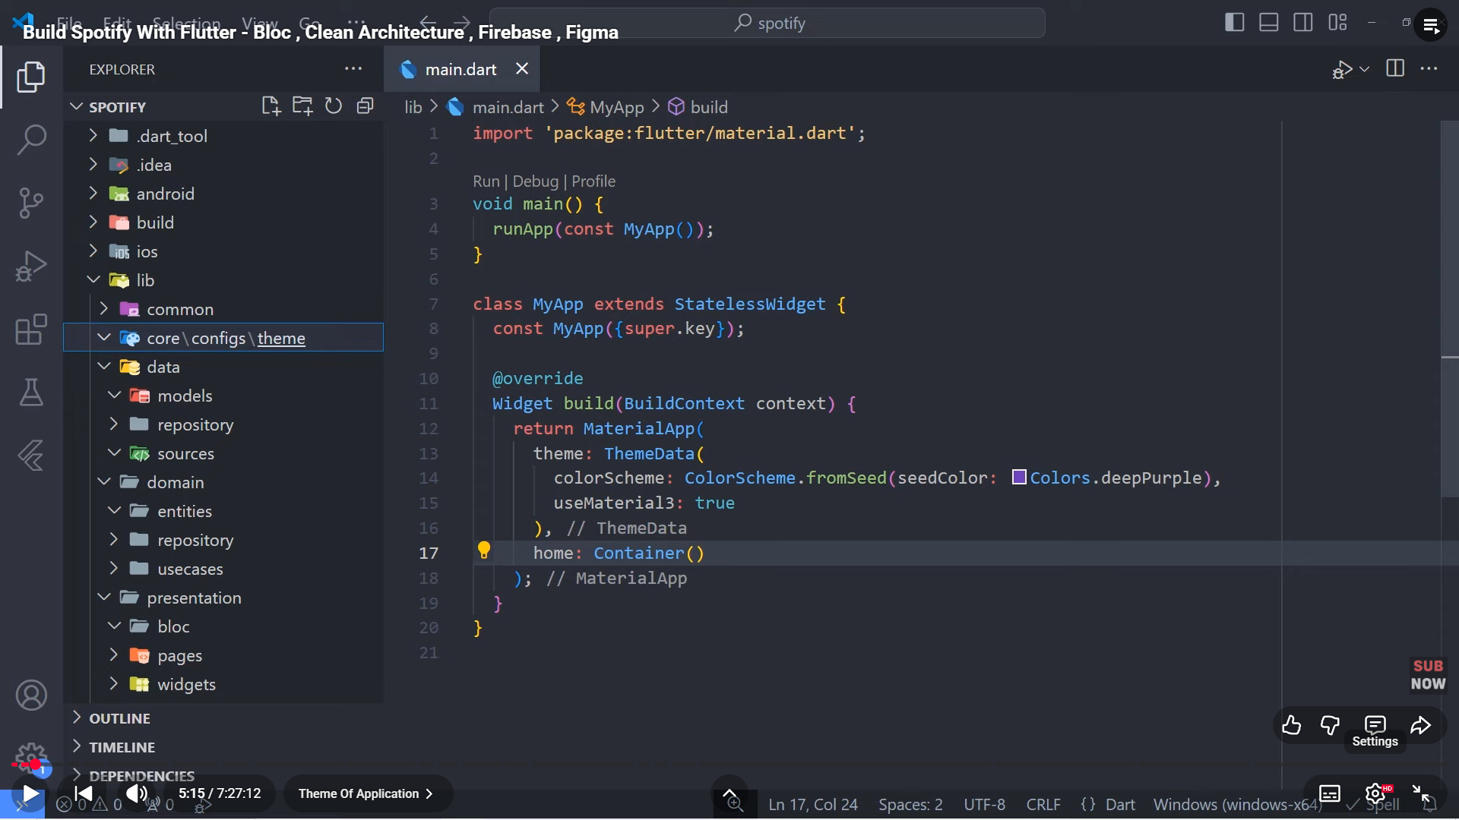

1. App_colors:

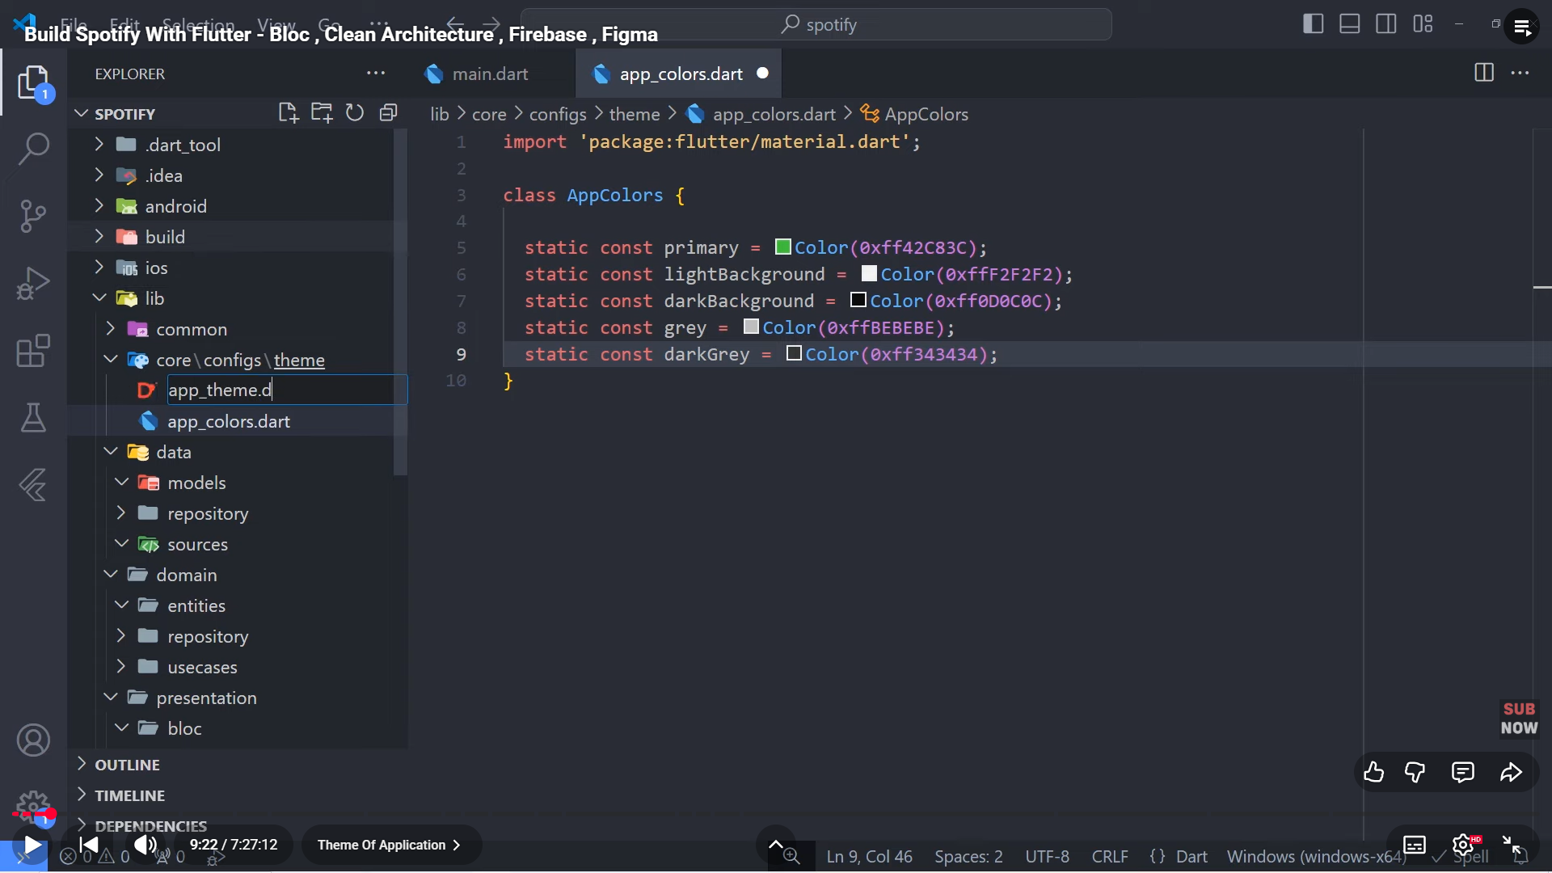

1. App_theme:

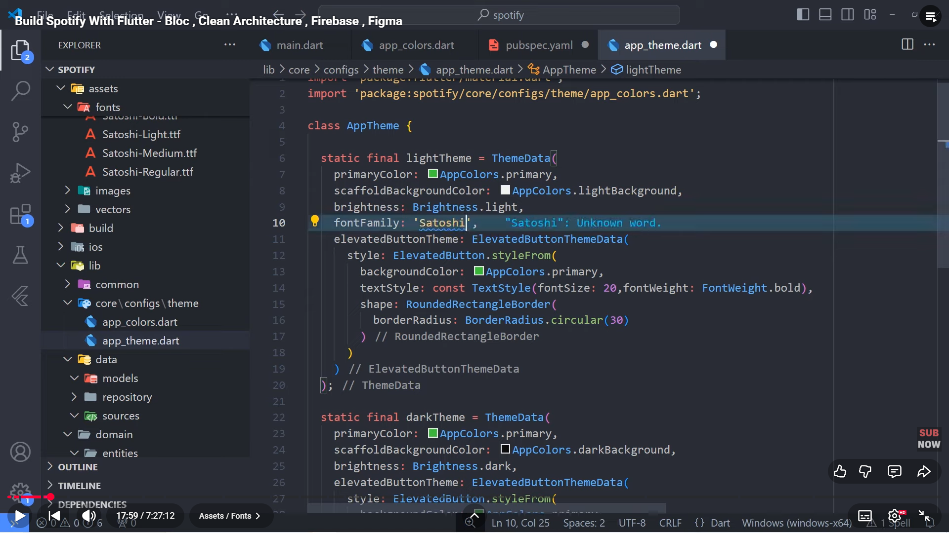

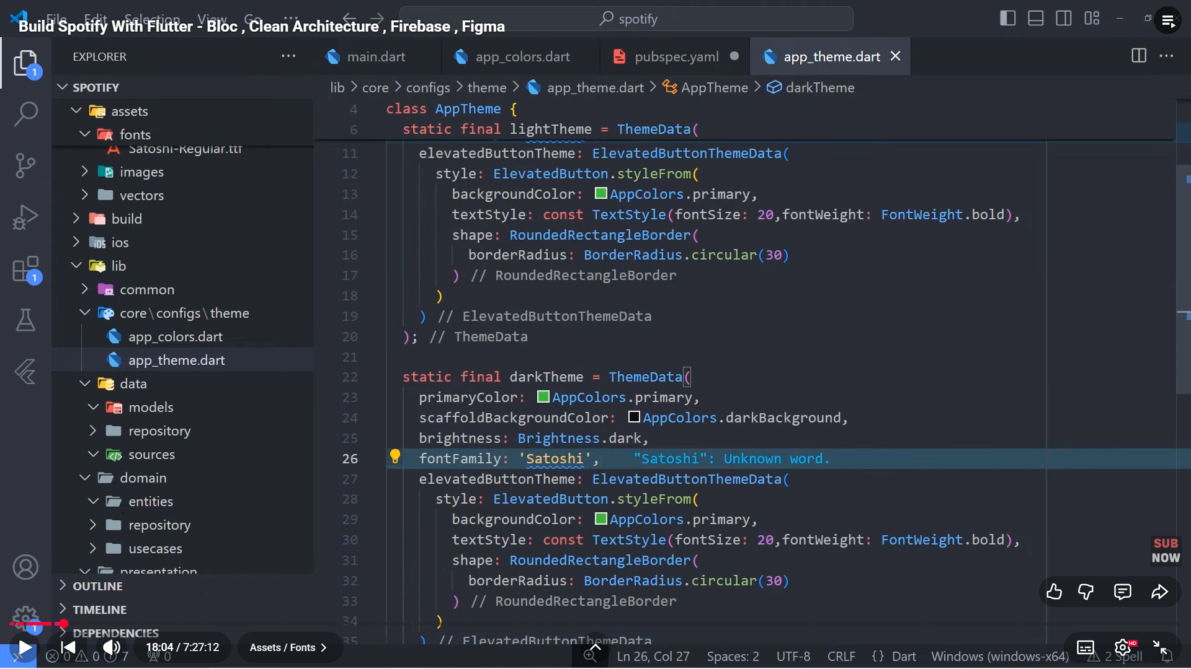

1. Configure:

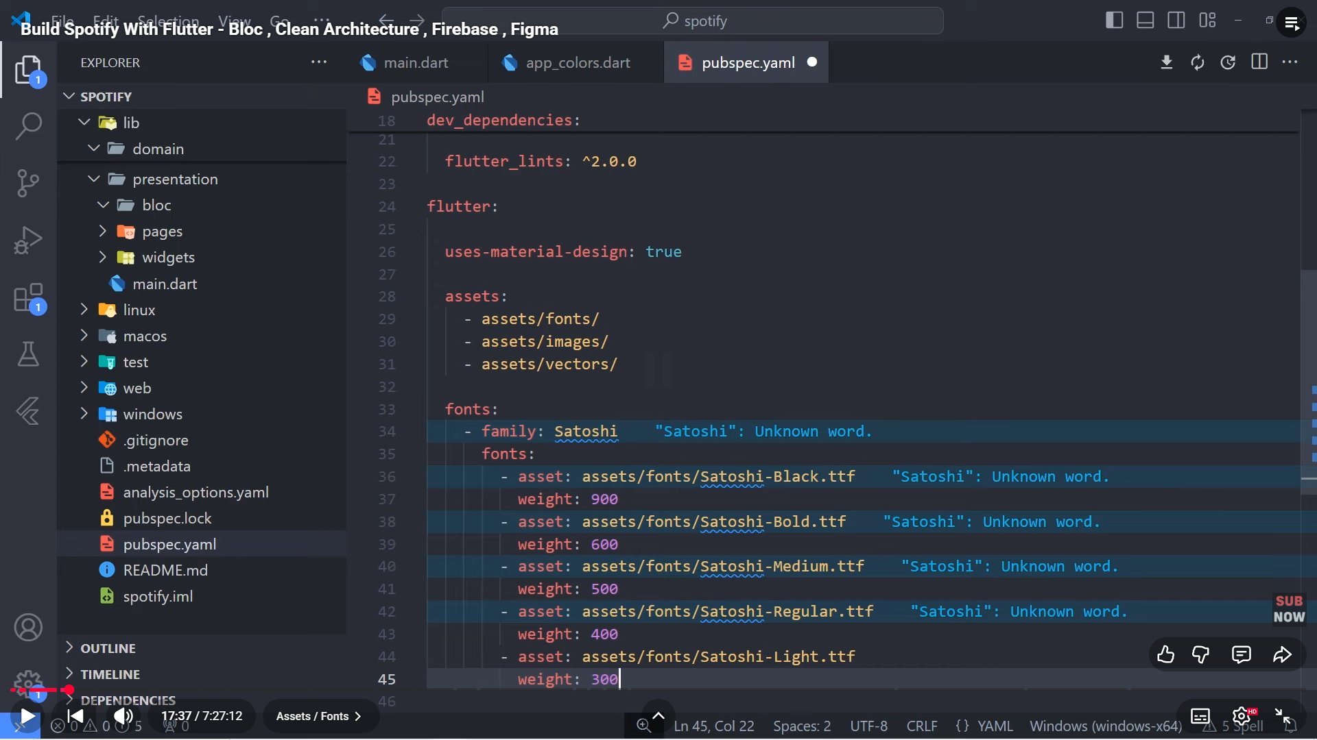

1. Create folder presentation/splash/bloc, pages/splash, widgets and assets inside core/configs

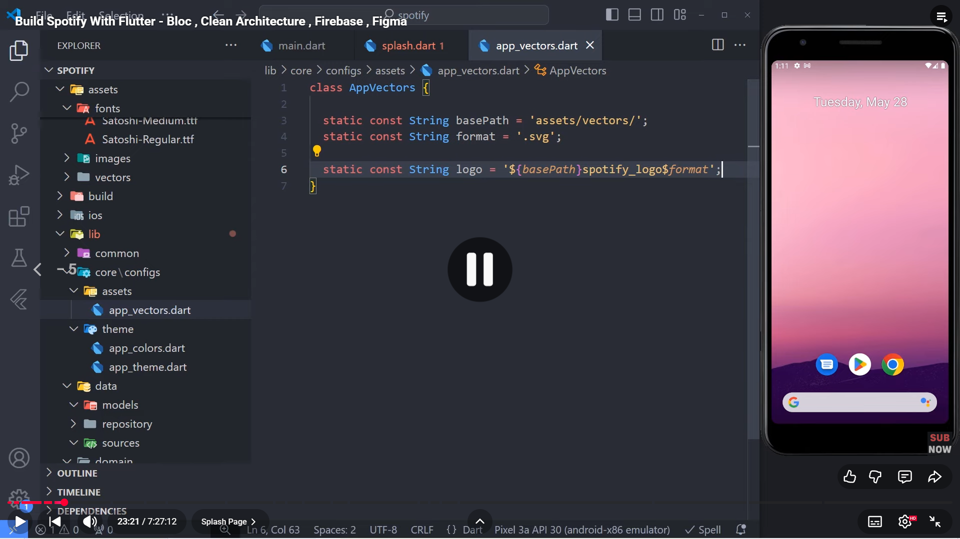

1. Add flutter_svg: in pubspec.yml after cupertino_icons: ^1.0.8